PROJECT TITLE: Online Course Enrollment System
SUBMITTED BY: Nipun Dhama
DATE: November 23, 2025
INSTITUTION: VIT Bhopal University

1. Introduction
Online Course Enrollment System is a Python-based command-line interface (CLI) application designed to streamline the process of managing student enrollments in an educational setting. It serves as a centralized platform for administrators to perform essential academic operations, such as registering new students, overseeing course selections, tracking enrollment statistics across different subjects, and maintaining an up-to-date student roster. This project demonstrates fundamental software development concepts including CRUD (Create, Read, Update, Delete) operations, data structure manipulation, and user input handling.
2. Problem Statement
Manual management of university enrollments using spreadsheets or paper records is inefficient, prone to human error, and difficult to scale. Administrators often face challenges in tracking which students are enrolled in specific courses, ensuring student IDs are unique, and quickly generating statistics on course popularity. There is a critical need for a simple, digital solution that can automate these record-keeping tasks, validate data entry in real-time, and provide instant access to enrollment status without the complexity of a full-scale enterprise resource planning (ERP) system.
3. Functional Requirements
The system must fulfill the following functional requirements based on the provided menu options:
- FR1 - Student Registration: The system shall allow the user to create a new student record by inputting a unique Student ID, Name, and an initial course selection from the catalog.
- FR2 - View Course Catalog & Statistics: The system shall display a list of all available courses and dynamically calculate and display the total number of students currently enrolled in each course.
- FR3 - View Student Roster: The system shall display a comprehensive list of all registered students, showing their ID, Name, and currently enrolled courses.
- FR4 - Add Course: The system shall allow an existing student to enroll in an additional course, provided the course exists in the catalog and the student is not already enrolled in it.
- FR5 - Drop Course: The system shall allow an existing student to remove a course from their enrolled list.
- FR6 - Remove Student: The system shall allow the user to permanently delete a student's entire record using their Student ID.
4. Non-functional Requirements
- NFR1 - Usability: The command-line interface must be intuitive, providing clear menu options and instructional prompts for inputs.
- NFR2 - Performance: Operations (registration, viewing lists) should execute instantly given the in-memory nature of the data.
- NFR3 - Reliability (Error Handling): The system must handle invalid inputs gracefully (e.g., entering non-existent course names, trying to register duplicate IDs) and provide informative error messages instead of crashing.
- NFR4 - Data Volatility: As a design constraint for this version, data stored in the system is temporary and will be lost when the application terminates (no persistent storage).
5. System Architecture
The application follows a monolithic, class-based architecture within a single Python script. It utilizes Object-Oriented Programming (OOP) principles where a single class, MultiCourseSystem, acts as the controller.
- Data Model: Data is managed in-memory using Python native data structures:
  - A dictionary (self.students) stores student records for fast lookups by ID.
  - A list (self.catalog) holds the predefined, static list of available courses.
- Controller Logic: Methods within the class handle specific business logic (e.g., register_student, update_enrollment).
- Interface Layer: The main() function runs an infinite loop to present the menu and capture user choices, acting as the interface between the user and the system logic.
6. Design Diagrams
The following diagrams illustrate the structural and behavioral design of the system.
Use Case Diagram
Workflow Diagram (Activity Diagram)
Class Diagram
ER Diagram (Entity Relationship)
Note: As this system uses in-memory Python dictionaries and lists for data storage rather than a relational database, a traditional Entity-Relationship (ER) diagram is not applicable. The data relationship is defined by the dictionary structure where a unique Student ID key maps to a value containing student details and a list of associated courses.
7. Design Decisions & Rationale
- Choice of Language (Python): Python was selected for its simplicity, readability, and strong support for dictionary manipulations, which are central to this project's data structure.
- In-Memory Data Storage (Dictionaries): The decision to use Python dictionaries instead of a database was made to keep the project lightweight and focused on logic implementation rather than database connectivity overhead. Dictionaries provide O(1) average time complexity for lookups, ensuring fast performance for ID validation.
- CLI Interface: A command-line interface was chosen as the fastest way to implement user interaction without requiring complex graphical user interface (GUI) libraries.
8. Implementation Details
The core of the system is the MultiCourseSystem class initialized in the main execution block.
- Data Structure: The self.students dictionary is the primary data store. Its structure is:
Python
{
'Student_ID_Key': {
'name': 'Student Name Value',
'courses': ['Course 1', 'Course 2'] # List of strings
}
}
- Logic Flow:
  - The program starts in the main() function, initializing the class instance.
  - A while True loop presents menu options.
  - Based on user input, the corresponding method of the MultiCourseSystem instance is called.
  - Methods typically ask for input (like Student ID), validate it (checking if s_id in self.students), perform the dictionary update, and print a success or error message.
9. Screenshots / Results
(Note to Student: Insert actual screenshots of your running application here. Below are placeholders for what you should include).
Screenshot 1: Main Menu & Student Registration
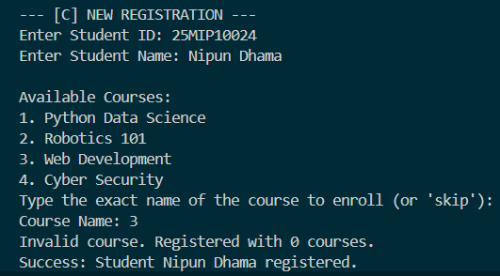
Screenshot 2: View Courses & Statistics
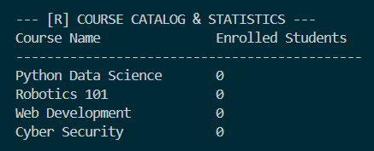
Screenshot 3: Student Roster View
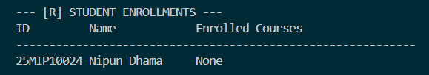
10. Testing Approach
A manual, black-box testing approach was used to validate the functional requirements. Test cases were executed via the application's menu.
Test Case ID | Description | Test Steps | Expected Result
TC001 | Register New Student | Select Opt 1, enter unique ID 'S01', Name 'John', valid course. | Success message. Student appears in Roster.
TC002 | Duplicate ID Check | Select Opt 1, enter ID 'S01' again. | Error message: "ID already exists."
TC003 | Add Course | Select Opt 4, enter 'S01', choose Add, enter valid new course. | Success message. Roster shows new course for S01.
TC004 | Drop Non-existent Course | Select Opt 4, enter 'S01', choose Drop, enter a course they don't have. | Error message: "Not enrolled in this course."
TC005 | View Stats | Register 2 students in "Robotics 101". Select Opt 2. | "Robotics 101" should show count of 2.

11. Learnings & Key Takeaways
- Gained practical experience in implementing CRUD operations using Python.
- Deepened understanding of Python dictionary methods (keys, values, items) for data manipulation.
- Learned how to structure a basic CLI application using loops and conditional statements to control program flow.
- Understood the importance of basic error handling to improve user experience.

12. Future Enhancements
- Data Persistence: The most critical enhancement is implementing file handling (CSV or JSON) or a database (SQLite) to save student records permanently so data is not lost when the program closes.
- Input Sanitization: Improving input handling to manage case sensitivity better (e.g., allowing "python" to match "Python Data Science").
- Expanded Catalog: allowing administrators to add or remove courses from the catalog itself, rather than having a hardcoded list.
- Graphical User Interface (GUI): Developing a frontend using libraries like Tkinter or PyQt to make the system more user-friendly.

